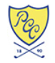

Director of Racquets

Plainfield Country Club

Edison, NJ

Our Rich Heritage

Founded in 1890 as the Hillside Tennis Club, Plainfield Country Club has enjoyed a revered reputation among golf and racquet enthusiasts alike. The golf course was designed by Donald Ross and opened in 1921. Starting in 2000, PCC’s golf course has undergone an extensive restoration and renovation program under the direction of architect Gil Hanse. Golf Digest, Golfweek and Golf Magazine all rank PCC’s course in the Top 100 in America.

Sports facilities also include an expansive racquets facility with 6 tennis courts, 4 platform tennis courts, 2 squash courts, a new aquatics center and the “West Nine” golf course. A renovation of the Historic Clubhouse will be completed in June 2019. The club prides itself as an active “Family Country Club with World Class Golf”. PCC’s many long tenured Department Heads are a tribute to the club’s commitment to career development, growth and stability.
Tennis, platform tennis and squash have been an integral part of PCC since its inception. The tennis courts, tennis shop, paddle courts, paddle hut and squash facility have all been renovated during the past few seasons. The Membership enjoys a vibrant recreational and competitive use of its racquet facilities with 21 total teams for Women, Men and Juniors. Members are also supportive of the highly active lesson programming in both tennis and platform tennis.

“Giving back” and hosting Championships have been priorities for PCC. Its history includes the 1978 U.S. Amateur, 1987 U.S. Women’s Open, the PGA Tour’s 2011 & 2015 Barclays, the 2017 Junior President’s Cup and countless regional and state championships. Acting as the host of PGA Tour events generated millions of dollars for local charities, including PCC’s First Tee of Plainfield program. PCC is the first private country club in the US to start and operation a First Tee program on its property.

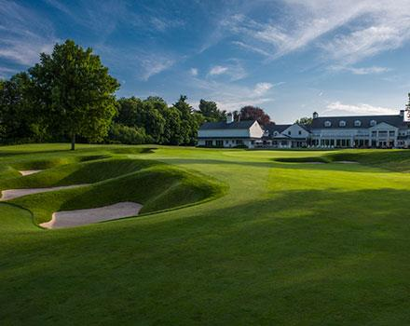

Position Description:

The Director of Racquets will oversee and manage the Racquets operation at Plainfield Country Club with the goal of consistently providing an exceptional experience for our Members, their families and their guests. He/She will also be responsible for achieving the Club’s critical financial objectives related to Racquet Operations. This position will report directly to Plainfield Country Club’s Chief Operating Officer, Scott Paris.

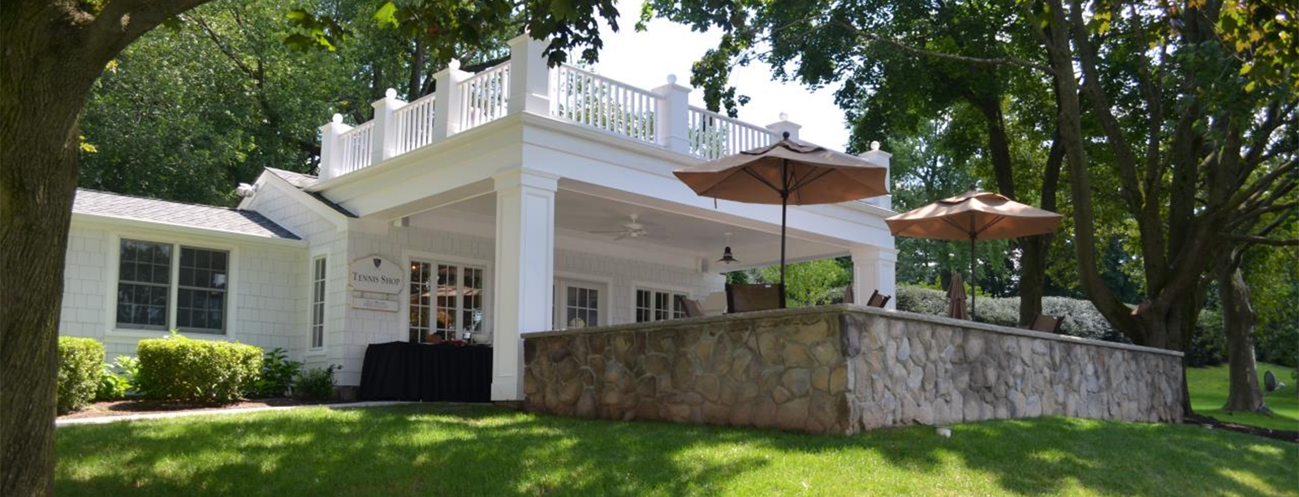

Key areas of responsibility include:

- Uphold the Plainfield Country Club mission statement and implementation of all Club policies and procedures.
- Recruit, hire, train, motivate, mentor and manage all racquet department staff.
- Maintain, refine and manage an innovative racquet event schedule that services all member and club needs.
- Provide a vibrant instruction program offering individual and group lessons for tennis, platform tennis and squash for all ability levels and ages.
- Manage all Women’s and Men’s paddle and tennis interclub teams in partnership with team captains.
- Oversee the court reservation system, monitoring of play and billing of all guest fees.
- Provide a Tennis Shop with the highest level of service and presentation.
- Enforce all rules and regulations governing Racquet facility usage.
- Oversee “Camp PCC” in partnership with the Head Golf Professional, Aquatics Director and Clubhouse Manager.
- Elevate participation levels in Squash, Mens Tennis and all Junior programs.
- Maintain close working relationships with the Chief Operating Officer, Greens & Grounds Superintendent, Head Golf Professional, CFO, Club House Manager and all other department heads.
- Assist the COO & CFO in the preparation of budgets, including forecasting and review of all racquet revenues and expenses on a monthly and annual basis.
- Establish goals and forecasts for all racquet programs and services, monitor and analyze reports.
- Manage all court maintenance and upkeep.
- Approve all weekly racquet staff time cards, payroll, purchase orders, and invoices.
- Assist with communications process to include website, App, weekly email, Instagram, signage, etc.
- Attend all staff, management, racquet committee, and other applicable meetings.
- Assist with New Member Orientation Program and integration to the Club.

Experience / Qualifications / Skills:

Including, but not limited to, the following:

- USPTA and APTA member preferred with 8 or more years of experience.
- Director experience at a high-end private club is strongly preferred.
- Excellent teaching and coaching skills in both tennis and platform tennis is required.
- Effective interpersonal skills that will lead to strong member relationships.
- Strong leadership skills with proven experience in recruiting, managing and motivating a dynamic team.
- Strong playing skills and a desire to play with Members and compete when appropriate.
- Ability to communicate effectively and professionally in both verbal and written formats.
- Pro Shop merchandising, buying and management.

Compensation and Benefits
The club will provide a compensation and benefits package commensurate with experience and qualifications. This includes but is not limited to:
- Competitive Base Salary: $75,000-$85,000 (commensurate with experience)
- 100% of Merchandise Concession proceeds
- Racquets Operations Target Bonus (10% of salary)
- 100% of Lesson Income (plus a percentage of the Assistant Professional’s lesson income)
- Benefits – 3 weeks’ Vacation Paid, 401K, Health, Dental, Vision, Disability, Life Insurance, Meals, USPTA/APTA Dues Paid, Education Allowance, Cell Phone Allowance

Application Instructions :

Application Deadline: May 31, 2019

Please submit your cover letter, resume and references to racquetsdirectorapplications@plainfieldcc.com

You can expect to receive an auto-reply confirmation that your documents have been successfully received. If you do not receive confirmation, please email Karen Larkin at karenl@plainfieldcc.com. Thank you.
Employer does not wish to receive phone calls.

