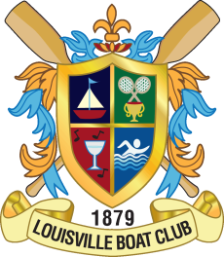

**POSITION:**

Head Platform Tennis & Tennis Staff Professional

**DIRECTLY REPORTS TO: INDIRECTLY REPORTS TO:**

Director of Racquets Operations General Manager/COO

**JOB SUMMARY:**

The Louisville Boat Club (LBC) is a 144 year old private club and has a rich history in racquet sports. The LBC is currently constructing two platform tennis courts and has 18 tennis courts (four indoor) and three squash courts and hopes to expand in the future. Currently the LBC has 115 members signed up in advance for the Platform Tennis Program and the excitement is building. The LBC will be hosting the 2016 Louisville International Open which will be aired on the tennis channel.

The Head Platform Tennis Professional will guide and develop the Louisville Boat Club’s Platform Program while assisting in all facets of the Club’s racquets operations. This includes the management of Club facilities, as well as facilitation of Club racquets programs, lessons, activities, special events, exhibitions, and tournaments. The Head Platform Tennis Professional will be focused on Platform Tennis, should have strong Platform credentials, and will be solely committed to the Louisville Boat Club.

Serious inquiries will be kept confidential and should contact the Racquets Director, Mark Fraley.

Compensation structure commensurate with experience.

Mark Fraley

Racquets Director

Louisville Boat Club

4200 River Road

Mfraley@louisvilleboatclub.com

Pro Shop: 502-896-0424

Cell: 502-648-9813